Chapter 7, Problem 20.

For the circuit in Fig 7.100,

v = 90e^{–50t} V
and

i = 30e^{-50t} A, t > 0

(a) Find L and R.
(b) Determine the time constant.
(c) Calculate the initial energy in the inductor.
(d) What fraction of the initial energy is dissipated in 10 ms?

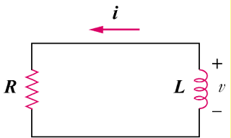

Figure 7.100
For Prob. 7.20.

